**Amazon Smbhav Hackathon 2024: Ideation Phase Submission Template**

**Welcome, Innovators!**

Thank you for participating in the Amazon Smbhav Hackathon 2024 Challenge! This template will guide you through the submission process for the ideation phase. Remember, your ideas have the power to transform the future of small and medium businesses. Let's get started!

**Instructions:**

* Please fill out all sections as completely as possible
* Section 1-3 once submitted would need to be carry forwarded as-is if your idea is selected for the next phase.
* Be clear and concise in your responses.
* If a section doesn't apply to your idea, simply write "N/A".
* Feel free to be creative and think big - we're excited to see your innovative ideas!

**1. Team Details**

**Team Name:**

**Team Members:**

1. Raj Dhapse
2. Varad Kottawar
3. V Vedhant
4. Srushti Chiddarwar

**2. Theme Details**

**Theme Name:** 1: Create an Amazon Product Listing using Social Media Content

**Theme Benefits:**

[Highlight the benefits of the chosen theme and how it can effectively support sellers in solving real problems]

**Enhanced User Experience:**

Automating the listing process streamlines how customers find and purchase products, avoiding social media inefficiencies. Customers benefit from reliable delivery, easy tracking, and return policies critical for satisfaction.

**Seamless Marketing and E-Commerce Alignment:**

The system aligns with social media marketing, creating Amazon listings that reflect the original promotional intent and style. This enhances coherence from social platforms to Amazon, where customers can easily find trusted, familiar product details.

**3. Idea and Approach Details**

**Solution Overview:**

Create a Bowser Extension and Website to generate product listing

1. **Data Extraction:** Fetches content such as captions, images, videos, and comments from the relevant platform.
2. **Instagram Scraping:** Uses instaloader or scraping as a fallback method for Instagram data extraction. (can add other social media platforms as well)
3. **Image Analysis:** Analyzes images for caption generation using BlipProcessor
4. **Video Analysis:** Extracts audio using whisper for transcription and applies OCR to video frames with cv2.
5. **Content Aggregation:** Collects data from text, images, and videos, then formats it into a structured JSON response.
6. **Textual Analysis:** Extracts sentiment, frequent keywords, and engagement metrics from captions and comments.

**Technical Stack:**

* **Frameworks and Technologies:**
  + Transformers: Open-source library by Hugging Face for NLP tasks (BlipProcessor, BlipForConditionalGeneration).
  + Pillow: Python Imaging Library for image processing.
  + Tesseract OCR: Open-source OCR engine for text extraction from images.
  + PyTorch: Open-source machine learning library for deep learning.
  + Whisper: Open-source automatic speech recognition system by OpenAI.
  + React: Open-source JavaScript library for building user interfaces.

* **Open Source Software:**
  + Whisper
  + Transformers
  + Tesseract OCR
  + React

**Decision Rationale:**

**Assumptions:**

1. **Instagram Content Accessibility**: Public Instagram posts, images, and videos can be accessed using instaloader or the Instagram Graph API (if authorized).
2. **Consistent Media Quality**: Instagram posts will generally have images and videos that are of high enough quality to perform analysis, such as caption generation, depth estimation, and audio transcription.
3. **Single Platform Focus**: The tool will be optimized specifically for Instagram, so platform-specific issues (like rate limits or API changes) will be handled for Instagram’s APIs or scraping methods.

**Constraints:**

1. **Rate Limits**: Instagram imposes API rate limits (e.g., for Graph API calls), which could affect the frequency of data extraction.
2. **Graph API Restrictions**: The Graph API may not allow full access to all content types (e.g., limited access to user-generated content in some cases).
3. **Private Content**: Only publicly available posts can be analyzed unless the user logs in and grants permission to access private data.
4. **Scraping Risks**: Using scraping tools like instaloader might lead to temporary bans or restrictions from Instagram if overused or improperly handled.

**Key Decisions:**

1. **Choice of Tools**:
   * **Instaloader for Data Extraction**: Choose Instaloader for Instagram scraping due to its ability to extract images, captions, and comments from public profiles or posts without requiring API credentials.
2. **Media Analysis Approach**:
   * **Image Captioning**: Used BlipProcessor for generating captions and Midas for depth estimation to analyze visual content from Instagram posts.
   * **Video Analysis**: Chose whisper for transcribing audio from Instagram videos and cv2 for extracting text from video frames via OCR.
3. **Output Format**: JSON will still be used to format the analyzed data, as it is easy to handle and integrate with web applications, offering a structured view of the image/video content and analysis.

**Innovation Highlights:**

* **Comprehensive Media Analysis**: Combines image captioning (BlipProcessor), depth estimation (Midas), and video transcription (whisper) for advanced media insights.
* **Unified Content & Sentiment Analysis**: Integrates visual and emotional analysis of content, combining image, video, and comment data for deeper insights.
* **Automatic Captioning**: Generates captions for images and videos based on content, enhancing engagement without manual input.
* **Privacy-Focused**: Processes only public data by default
* **Instagram API Integration**: Seamless integration with Instagram’s APIs and scraping methods for efficient data extraction.

**Feasibility and User-Friendliness:**

**Realistic Implementation:** Utilizes established tools like instaloader and models like BlipProcessor and Whisper. The focus on Instagram simplifies data extraction.

**User-Friendliness:** Features an intuitive UI that requires no technical skills. Users can easily input URLs and view analysis results.

**Potential for Success:** The solution targets a niche market (Instagram content creators and marketers), is adaptable to platform changes, and can be regularly updated with new features, ensuring long-term relevance and growth.

**Success Metrics:**

[Consider which success metrics, such as how happy users are, how well the solution performs, and how easy it is to make subsequent updates, etc., can help us/judges understand how effective, consistent, and scalable your solution is.]

**Performance**: Speed of data fetching, accuracy of content analysis (image/video), and real-time generation of insights without lag or downtime.

**Scalability**: Ability to handle increasing data volume, media content, and concurrent users with consistent performance.

[raj11dhapse@gmail.com](mailto:raj11dhapse@gmail.com) add the docker thing.

[varadkottawar02@gmail.com](mailto:varadkottawar02@gmail.com) kaay re

**4. Methodology/Architecture Diagram**

An architecture diagram is a crucial component of your submission. It provides a visual representation of your solution's structure and flow. Please include one or more of the following:

* Flow Chart
* Wireframes
* Block diagram
* Graphical representation (Bar graph, Histogram, Pie charts, Heat maps)

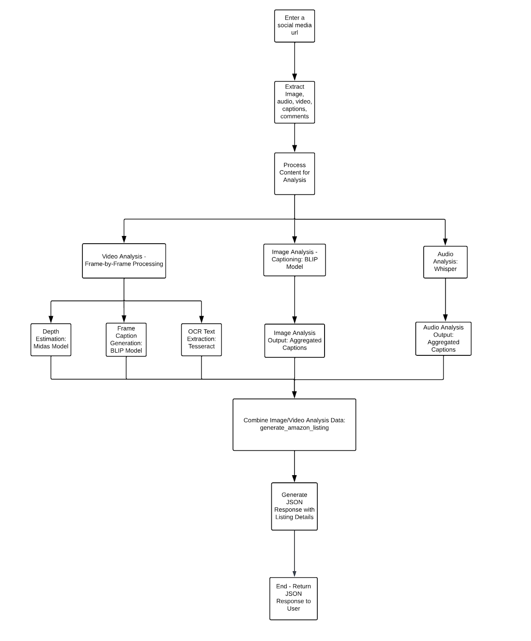

[**https://lucid.app/lucidchart/f5d8801b-173c-421e-a7a4-b9a6bfa407ac/edit?invitationId=inv_87e8cd68-c795-4bd5-9c1b-2ae417918d5d**](https://lucid.app/lucidchart/f5d8801b-173c-421e-a7a4-b9a6bfa407ac/edit?invitationId=inv_87e8cd68-c795-4bd5-9c1b-2ae417918d5d)

[Insert your diagram links here]

**Submission Checklist:**

**⇒** All team details are filled out

**⇒** Theme details and benefits are clearly explained

**⇒** Idea and approach details are comprehensive

**⇒** Architecture diagram(s) are included

**⇒** All sections are completed to the best of your ability

Thank you for your submission! Your innovative ideas have the potential to make a significant impact on SMBs across India. We look forward to reviewing your proposal and wish you the best of luck in the challenge!